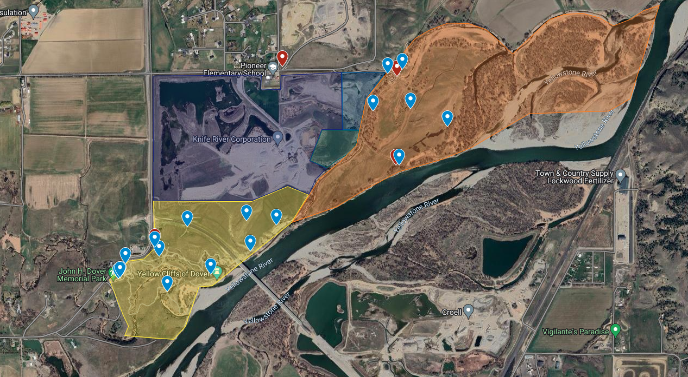

HQ, entrances, bathrooms
Area 4 Headquarters

Bathroom
Projects

Area 4 Yellow Zone projects
Russian Olive Removal-Trim limbs and cut stumps 6-8" from ground with saw. Place flag, must be sprayed with herbicide w/in 15 minutes. All NON-Russian Olive shrubs (mostly buffalo berry) have been flagged - if in doubt, do not cut. Pile limbs in dense piles. (Small chain saws and saws welcomed to use)

Old Fence Removal-Remove old metal and wood posts, roll up and discard any/all barbed wire fencing. DO NOT REMOVE new/straight posts and fencing

Area 3 and 4 entrance
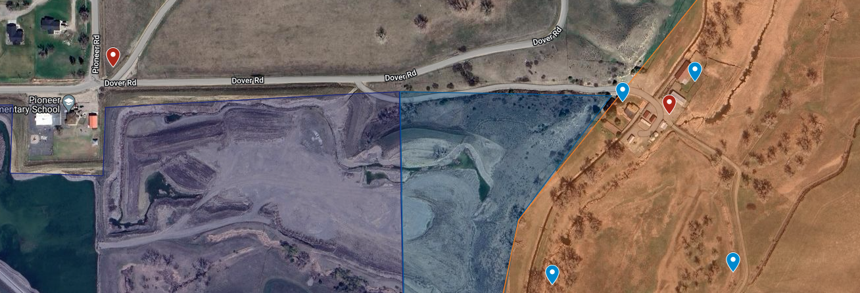
Area 3 Gray Zone Headquarters
Gate Keeper
Church Vans Park at Pioneer School Park Church Vans will carpool participants to project
Pioneer School
Gate Keeper

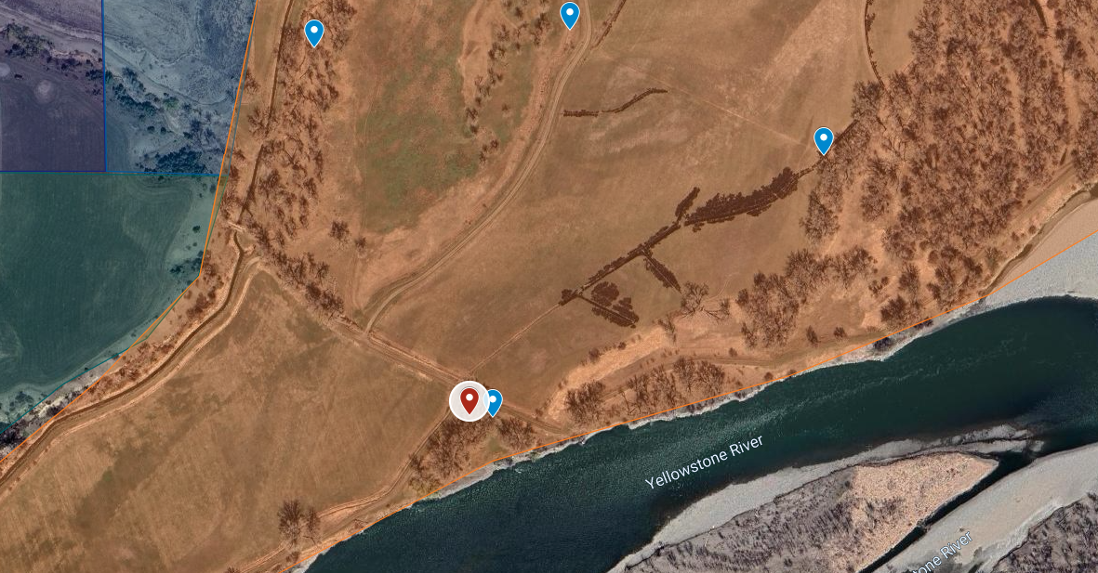
Area 3 Gray Zone slough fencing
Fence Removal
Fence Removal
Russian Olive Removal
Area 4 Headquarters with Yellow Flag
Porta Potty
Russian Olive Removal

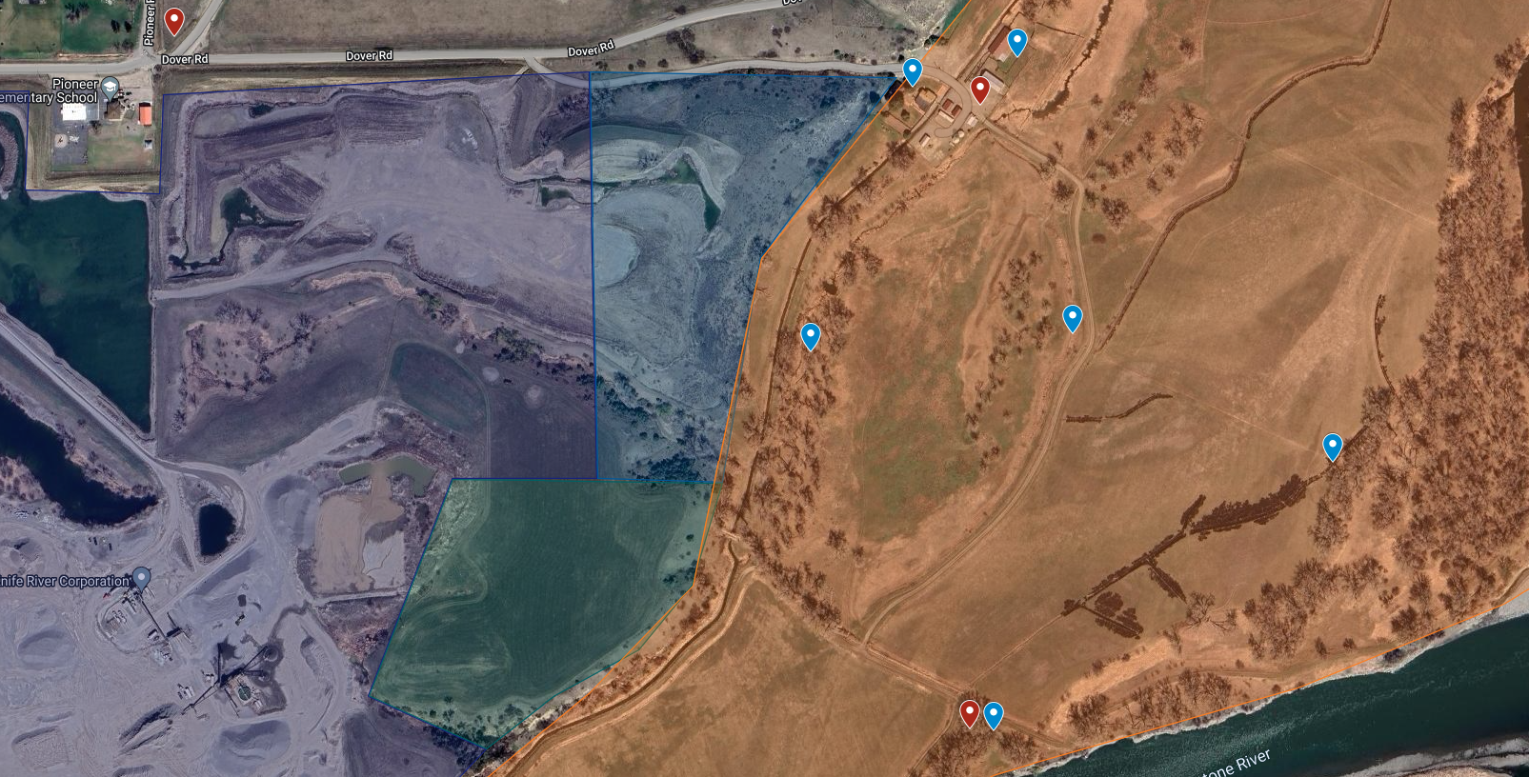
Area 4 Yellow Flag
Area 3 Slough Fencing
Russian Olive Removal
Area 4 Headquarters Yellow Flag
Area 3 Headquarters with Gray Flag
Porta Potties
Old Fence Removal
Russian Olive Removal

